Curriculum Vitae
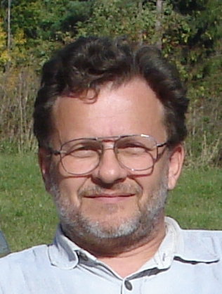
Personal Data:
name: Gergely Detzky
born in: Miskolc, 26 October 1957
address: 2230 Gyömrő, Attila u. 7.
phone: +36 70 6109493
email: g.detzky@gmail.com

Education:
1994 – 1997: Eötvös Loránd University of Budapest:
PhD Absolutorium in Exploration Geophysics
1982 – 1985: Miskolc University of Heavy Industry,
postgraduate degree in Economics of Mining Industry
1976 – 1981: Moscow Geological Prospecting Institute
MsC graduate degree: Mining Engineer – Geophysicist
Skills:
Russian : written and spoken: experienced,
English : written: experienced | spoken: intermediate
Programming languages actively used for IT development:
VBA, PHP, SQL, HTML, CSS, C, Lisp
Employer:
1981–2018 Eötvös Loránd Geophysical Institute (ELGI)
(Merged into the HGMS – Hungarian Mining and Geological Survey in 2017)
1981–2003: Department of Seismic Exploration
2003–2018: Department of Geophysical Mapping

Geophysical field works abroad:
1986: Austria, shallow seismic refraction processing for field statics (6 weeks)
1993: Great Britain, User training of ProMAX seismic data processing system (1 week)
1994: Syria, field measurement and processing of shallow seismic refraction (8 weeks)
2005: Albania, transient EM survey for a polymetallic indication (3 weeks)
2007: Mongolia, transient EM survey for a polymetallic indication (4 weeks)
Professional Experiences:
2008 - : Database back-end and front-end development
Public database of Reports of Hungarian Mining and Geological Survey
Reference: http://mafgba.mfgi.hu/public2/index.htm
Non-public meta-database of data resources of HMGS
Relevant web IT environment elements:
PostgreSQL, PHPrunner back-end developing environment, HTML, CSS
Development of numerous project- and corporate databases using dedicated Excel-VBA and Q-GIS applications: (relevant examples)
- Seismic velocity database of Hungary with velocity conversion capabilities (between VSP, RMS, acoustic seismic velocity data)
Reference: „Greg DETZKY (2008) - Parametric interpolation of seismic velocity field” Geophysical Transactions 2008 Vol. 45. No.3. pp. 157-177
- Database of mass storage media of geophysical data
(the system was also individually used by Horison Hungary Ltd.)
- Database of Rare Earth Metallic Resources of Hungary
- Database of Mining Waste Facilities of Hungary
- Database and data visualisation environment for archived laboratory analysis data of coal samples of Hungary.
Planning, management and performance of geoelectrical field measurements in numerous exploration and geoengineering projects
2004-2008: Taking part in the EU co-financed international development projects
- KINGA project (Key for Internet based Geophysical data Access): as the individual writer of the succeeded project proposal, as a participant of planning and development team, individual developer of geophysical thesaurus database of KINGA portal (MySQL, PHP).
Reference: https://kinga.elgi.hu/kinga_html/
- GEOMIND project (International geophysical database development by a consortium of organisations from 11 countries) as the work package leader of multilinguistic geophysical thesaurus database development. (Internet service discontinued after 5 years at the Geological Survey of Denmark since the end of financing.)
1990-2003: Leader of database development project of seismic data of ELGI
Relevant IT background (in DOS): dBASE, Clipper, C, AutoCAD, Paradox
1981-1989 Taking part in numerous seismic data processing and interpretation projects
Planning and management of seismic field measurements,
(between 1985–1987 as the head of dynamite seismic crew with 40 workers).

