Viktória BÁNHEGYI, +36 30 546 3039, banhegyivi@gmail.com

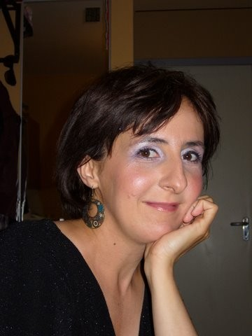 CURRICULUM VITAE

PERSONAL Viktória Bánhegyi (born Viktória Kelemen, 03/09/1972, address 1032 Budapest, Bécsi str)

WORK EXPERIENCE

2000 – 2014 Pázmány Péter Catholic University, Faculty of Law and Political Sciences, Deák Ferenc Postgraduate, Educational organizer and promoter (organise and monitor postgraduate courses and workshops, make contracts, draw up website, make HR plans, administrative work and supervise) 2004-2014,
Faculty of Law and Political Sciences, European Study Centre, Erasmus coordinator (organise and document the undergraduate and postgraduate EU courses, workshops, make network, coordinate students’ and teachers’ mobility program) 2000-2003.
1999-2000 Nokia Hungary – ICM Ltd, Humanpolitical and regional assistant, Telecom Project DCS 1800 (recruitment, HR processes, organize trainings, trips, international teamwork, contact with Lemminkäinen colleagues in Finland
1998-1999 Language teacher, Hungarian as FL (private lessons (CEU etc. through Russian, Estonian and English language)
1997-1999 Language teacher, ELTE BTK (Estonian as FL for university students)
1996-1997 Language teacher, University of Tartu (Hungarian as FL for university students, organize conferences)
1995 Journalist, newspaper Heti Magyarország (interviews)

EDUCATION

1991-1997 ELTE University, Budapest, Faculty of Arts. Majors: Russian and Finno- Ugrian Studies, Cultural Management. Qualifications: teacher, cultural manager, Degree: MA

STUDIES ABROAD

1996-1997 University of Tartu, Estonia (Scholarship on the Faculty of Arts, Estonian as FL Department)
1997 University of Turku, Finland (conference of IFUSCO, Lecture theme: the Estonian folk-songs)
1995 University of Leuven, Belgium (EU-Summer Course in English, CAFED 2: Christian Academy for European Dialogue)
1994 University of Prague, Czech Republic (EU-Summer Course, CAFED 1)

Viktória BÁNHEGYI, +36 30 546 3039, banhegyivi@gmail.com

COURSES

2011 Poszeidon Course (PPKE JÁK)
2010 Marketing and Excel Course (PPKE JÁK)
2009 Pro Read - Speed Reading Course (PPKE JÁK)

2007 Neptun Data Base System Course (PPKE JÁK)
2004 Neptun Data Base System Course (PPKE JÁK)
2001 Planning and programming of the Projects for Structural Funds, Tempus Public Foundation (in English language)
2000 SYSTRA Course, Nokia Head Office, Budapest (in English language)
1999 Lemcon Basic Telecom Training, Etyek (in English language)

LANGUAGE SKILLS

English Medium level (use at work, summer courses, courses at the university)
Russian Medium level now (MA degree)
Estonian Medium level (MA, 1 year in Estonia)
Finnish Basic level (final exam at the Finno-Ugrian Department, use at Nokia work)

COMPUTER SKILLS

Office, Neptun, Complex E-Storage of Laws

OTHERS Driver’s licence, B category (2001)

PERSONAL SKILLS

Accuracy, executive ability, team player, motivated to the clients, respect, loyalty, good communication, individual work ability, legal point of view

CIVIL WORK, SPORTS, HOBBIES

volunteer at Salesians, provide Csángó educational program, dance, play badminton, read, tours, cinema

Date: September 2014

